Saudi Arabian
Mining Company
(MAADEN)

SAP Business Network (SBN) Portal User Manual
How to Maintain and Update Profile

Supplier Registration Questionnaire Update
The Supplier contact can update their registration questionnaire on SAP Business Network.

- Log into your SAP Business Network Account

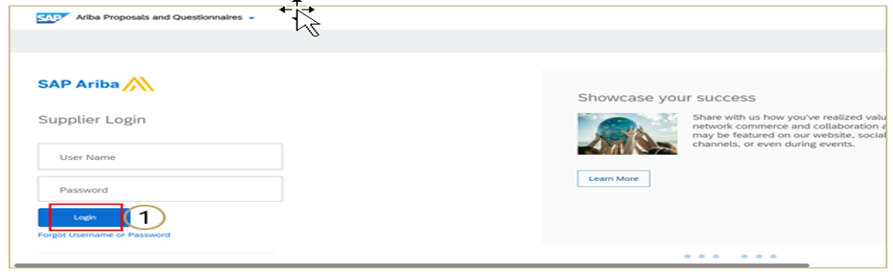

- On the questionnaire Dashboard, click on Supplier Registration Questionnaire

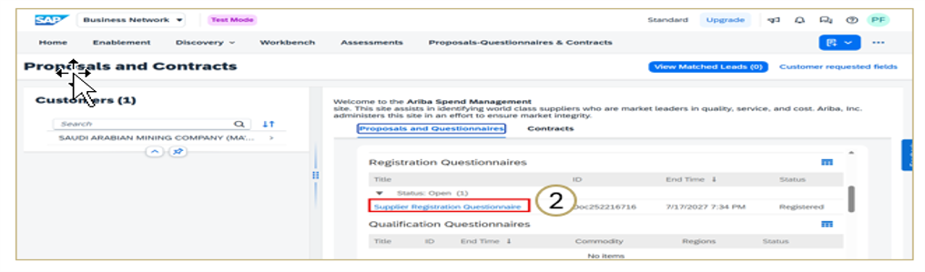

- Click on Revise Response and then click on OK
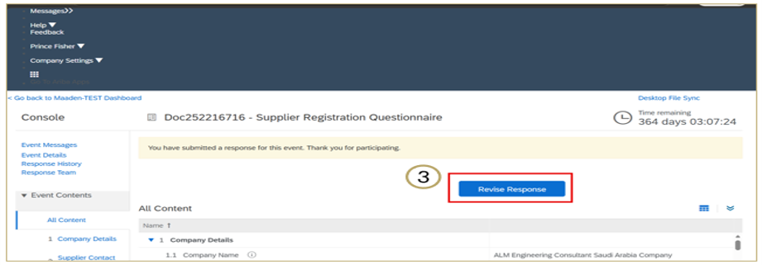

- Update the questionnaire and click on Submit Entire Response
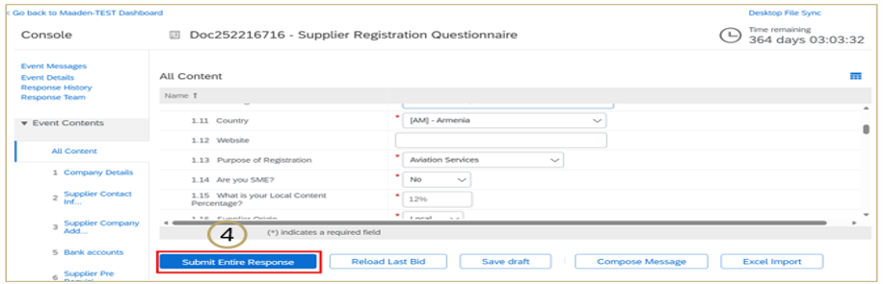

- Click OK
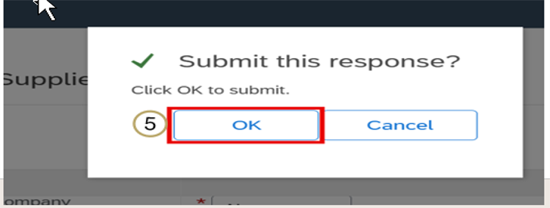

- Approval confirmation email sent to Supplier contact
