MA’ADEN FIRMLY ESTABLISHES SAUDI ARABIA’S POSITION AS A GLOBAL EXPLORATION HUB WITH GOLD AND COPPER DISCOVERIES

Riyadh, Saudi Arabia. 15 January 2025: Saudi Arabian Mining Company (“Ma’aden”) has announced significant updates in its efforts to explore and unearth Saudi Arabia’s mineral endowment at the Future Minerals Forum 2025:
- The achievement of promising gold and copper intercepts in the Arabian Shield, with a brand-new gold discovery at Wadi Al Jaww and further success at Jabal Shayban, in a first set of drill results which indicate an exciting new potential gold and copper district.

- New drilling results from Ma’aden’s flagship Mansourah - Massarah gold mine showing strong gold mineralisation, building on the exploration program’s previous success.

- Ma’aden continues to undertake one of the world’s largest single-jurisdiction exploration program in the Arabian Shield.

Promising intercepts, including new gold discovery, continue to mark the Arabian Shield’s prospectivity
Promising gold and copper intercepts at Wadi Al Jaww and Shayban in the Arabian Shield are the first set of drill results in an exciting new potential gold and copper district.
Ma’aden revealed multiple intercepts of recoverable gold and copper grades in the exploration areas of the Shayban EL at Blocks 6 and 7. The assay results to date indicate wide intersections of gold mineralization at Wadi Al Jaww and gold and copper mineralisation at Jabal Shayban. Mineralisation at both sites occurs at shallow depths ranging from 20 to 200 meters, with the mineralization extending deeper and in all directions.
Jabal Shayban has long been a hotspot for mineral exploration, with the earliest programs dating back to the 1940s. However, Wadi Al Jaww is a potential brand-new discovery, with no prior exploration work undertaken at the site. Ma’aden’s potential success at both sites showcases the exceptional capability of Ma’aden’s exploration team to successfully unlock and unearth new potential orebodies in the Kingdom.
The exploration project remains at an early stage, and Ma’aden’s understanding of the mineralized zone is still developing. Ma’aden does not yet have enough information to estimate the size and quality of the mineralization or to estimate the Mineral Resource. Work to assess and interpret the data acquired so far is ongoing and will inform drilling activities through 2025.
The report at appendix 1 contains a detailed description of the work undertaken and the results of the program so far.
Latest gold findings announced at Mansourah Massarah, building on previous drilling success
Ma’aden also announced further results of its drilling programs at its flagship Mansourah - Massarah gold mine, continuing to demonstrate strong gold mineralisation below the current pit design as well as a significant high-grade extension at depth, highlighting the underground potential beneath the current open pits at Mansourah - Massarah. The latest results build on successful gold drilling results at Mansourah - Massarah announced by Ma’aden in December 2023, which showed high grade intercepts including 61m grading at 10.4 g/t Au and 20m grading at 20.6g/t Au within 400m of the mine.
These latest results show significant high-grade mineralisation has been intersected outside of previously modelled mineralisation domains, at extents up to 220m below the deepest part of the current open pit mine.
Bob Wilt, CEO of Ma’aden said, “We’ve been making significant investments in exploration in recent years, with the launch of the world’s largest single-jurisdiction mineral exploration programs. Through the work we have undertaken in recent years, the raw prospectivity of the Kingdom has been proven. The results announced today provide a further boost as we continue to accelerate drilling activities across our exploration program in 2025.
“We have committed to establishing mining as the third pillar of the Saudi economy, in line with Vision 2030. These announcements and the progress we continue to drive forward with at pace is indicative to the reality that that has now become. The focus that the kingdom has placed on accelerating the mining and minerals sector has created significant opportunities for growth and development.”
These results continue to strengthen Ma’aden’s view that an underground operation could be sustained at Mansourah - Massarah and drilling is planned for 2025 to further grow and convert Mineral Resources estimates.

END

Appendix 1

Wadi Al Jaww and Jabal Shayban

Background
Ma’aden have achieved a very promising first set of drilling results at its exploration program at Wadi Al Jaww and Jabal Shayban, both exploration targets are located within Shayban EL, Block 7 14433119 and Block 6 14433118 respectively. The area is approximately 150km southwest of Maaden’s Mahd Ahd Dahab mine and 150 km northeast of Jeddah city, 200 km south of Madinah city all accessible by road.
Ma’aden have identified gold intercepts at Wadi Al Jaww and gold and copper intercepts at Jabal Shayban. Assay results to date indicate relatively wide intersections of gold, and copper-gold mineralisation at relatively shallow depth ranges from 20 to 200m. The mineralisation remains open at depth and to the east, west, north and south.
No historical work has been reported at Wadi Al Jaww, it has been discovered by Maaden with an effort of collective assessment of the Arabian Shield with several target generation approaches and conceptual, theoretical ideas. Jabal Shayban project has a long exploration history with initial exploratory drilling completed by DMMR from the year 1940, and 1980’s with some regional studies and did assessment of different targets in the region. Detailed exploration was done in 1992 –1994 (BRGM and DMMR; BRGM-TR-15-3) by 36 DD holes bringing total drilled to 5,174.45 meters.

Geology and Mineralization
The exploration area is located on the crustal scale suture zone (NE-SW trending ophiolite decorated Nakasib-Bir Umq Suture) between the Hijaz and Jeddah terranes and underlain by metamorphosed volcanic, volcanoclastic and volcano-sedimentary rocks assigned to the Samran and Rabiagh group of Late Proterozoic age which have been intruded by mainly post-tectonic plutons of varying composition, volcanic rocks ranging in composition from basalts to rhyolite (although andesitic and dacitic varieties predominant). The mode of occurrence ranges from subaerial to subaqueous lava flows, domes, and hyaloclastites and from conglomerate to fine-grained, distal water laid tiffs.
Jabal Shayban mineralization is related to the Shayban lower member of volcanic breccia and rhyolitic tuff (quartz crystals >5mm), massive to semi-massive sulfides hosted by volcanic breccia. The gold-zinc-copper sulfides mineralization is principally associated with volcanic breccia, the clasts of country rock are generally silicified and intensely altered by chlorite.
Wadi Al Jaww is hosted by intrusions of the Al Kamil Suite ranging in composition from granodiorite, diorite to tonalite. Mineralization represents various alteration assemblages (propylitic, potassic, weak sericite-chlorite, silica, and carbonate alterations) and characterized by sheeted chalcopyrite ± quartz veins form discrete domains separated by areas of fewer veins.

Further Details:
Wadi Al Jaww results demonstrated significant gold mineralisation from surface and extended down to 200m at depth which is a follow-up on a series of exploration activities including stream sediment, channel sampling and geological mapping.
The significant gold mineralisation intersected represents only a portion of the full Phase 1 drill program, which is expected to test the 4km strike length of the discovery area. These results triggered an immediate expansion of drilling activities for the remainder of 2024 into 2025 at the exploration site.
While results are encouraging, the exploration project is still at an early stage and drilling to date does not allow sufficient understanding of the mineralized body to assess the potential size or quality of the mineralisation nor to enable estimation of a Mineral Resource. The assessment and interpretation of existing data is ongoing and will be used to help guide the drilling through 2025.
In Jabal Shayban property historic drilling has been focused on gossanous outcrops and surface geochemical anomalies shown in Figure 5, with number of holes drilled with RC and diamond core drilling to test gossanous rocks yet to understand nature of volcanic-hosted massive sulfide (VHMS) mineralization. Recent target identification work with large number of surface geochemistry, structural interpretations included re-interpretation of historic drill hole geology, modern VHMS understanding, volcano-stratigraphy and extensive IP/RES, gravity and ground magnetic survey completed in 2024. The re-assessment was followed by initial program to further test the contacts of volcanic breccia and rhyolitic tuff. The re-assessment was followed by three drill holes to further test the contacts of volcanic breccia and rhyolitic tuff (Figure 2). Despite historical drilling results has significant Au and Cu intersections, with modern multi acid assay techniques with precise targeting methodologies Maaden achieved one of the largest intersections of VHMS style mineralization in the Arabian Shield.

Exploration Highlights
The regional Exploration program in the Shayban area is focused on identifying potential deposits of high grade and developing these into mineable resource with much of the focus in 2024 and 2025 on delineating and defining the full extent of the identified area of potential discovery. Drilling is currently in progress.
The following table provides a summary of important assessment and reporting criteria used at the Wadi Al Jaw and Jabal Shayban the reporting of Exploration Results in accordance with the Table 1 checklist in The Australasian Code for the Reporting of Exploration Results, Mineral Resources and Ore Reserves (The JORC Code, 2012 Edition). Criteria in each section apply to all preceding and succeeding sections.

JORC Code, 2012 Edition – Table 1 report template

Section 1 Sampling Techniques and Data
(Criteria in this section apply to all succeeding sections.)
Criteria | JORC Code explanation | Commentary
Sampling techniques | - Nature and quality of sampling (e.g. cut channels, random chips, or specific specialised industry standard measurement tools appropriate to the minerals under investigation, such as down hole gamma sondes, or handheld XRF instruments, etc). These examples should not be taken as limiting the broad meaning of sampling.  - Include reference to measures taken to ensure sample representivity and the appropriate calibration of any measurement tools or systems used.  - Aspects of the determination of mineralisation that are Material to the Public Report.  - In cases where ‘industry standard’ work has been done this would be relatively simple (e.g. ‘reverse circulation drilling was used to obtain 1 m samples from which 3 kg was pulverised to produce a 30 g charge for fire assay’). In other cases more explanation may be required, such as where there is coarse gold that has inherent sampling problems. Unusual commodities or mineralisation types (e.g. submarine nodules) may warrant disclosure of detailed information. | - Diamond drill core is photographed, logged, sawn to half and samples by the Maaden personals at the onsite core yard.  - Diamond drill core (DD) HQ half core is sampled by geological (lithological, alteration and mineralisation) contacts with minimum of 0.3m and maximum length of 1.4m  - Logging and assays protocol in place from the start of the project as in 2023.  - Chanel sampling is conducted as continues chip sampling with chisel and hammer along the track, with starting coordinate and every end of samples coordinate marked and picked with differential GPS.  - A certified reference materials (CRM) inserted into the sample stream in every 20th sample, blanks from granite samples inserted at rate of 1 in every 20 intervals. Coarse duplicate and pulp duplicates are inserted at rate of 1 in every 20 samples.  - The remaining half cut core is stored on site for future works and references.  - Pulp from the ALS is returned to site after 6 months for storage at the request of the client for further works when needed.
Drilling techniques | - Drill type (eg core, reverse circulation, open-hole hammer, rotary air blast, auger, Bangka, sonic, etc) and details (eg core diameter, triple or standard tube, depth of diamond tails, face-sampling bit or other type, whether core is oriented and if so, by what method, etc). | - The diamond drill core is obtained generally using HQ diameter drilling, but occasionally dues to ground condition, holes often start with PQ diameter core.  - Where downhole surveying was undertaken, it was conducted using a Reflex Ez- Trac multi-shot survey instruments.  - All DDH were orientated at using a Reflex ACT II orientation tool.
Drill sample recovery | - Method of recording and assessing core and chip sample recoveries and results assessed.  - Measures taken to maximise sample recovery and ensure representative nature of the samples.  - Whether a relationship exists between sample recovery and grade and whether sample bias may have occurred due to preferential loss/gain of fine/coarse material. | - Drilling recovery is recorded for every run and in general there is excesses of 95% recovery.  - There is no bias with grade and core recovery noted so far in the obtained results.
Logging | - Whether core and chip samples have been geologically and geotechnically logged to a level of detail to support appropriate Mineral Resource estimation, mining studies and metallurgical studies.  - Whether logging is qualitative or quantitative in nature. Core (or costean, channel, etc) photography.  - The total length and percentage of the relevant intersections logged. | - Diamond core was photographed, logged following Maaden logging procedure in RR1.  - Downhole information logged include Lithology, Structures, Alteration, Mineralization.
Sub-sampling techniques and sample preparation | - If core, whether cut or sawn and whether quarter, half or all core taken.  - If non-core, whether riffled, tube sampled, rotary split, etc and whether sampled wet or dry.  - For all sample types, the nature, quality and appropriateness of the sample preparation technique.  - Quality control procedures adopted for all sub-sampling stages to maximise representivity of samples.  - Measures taken to ensure that the sampling is representative of the in situ material collected, including for instance results for field duplicate/second-half sampling.  - Whether sample sizes are appropriate to the grain size of the material being sampled. | - DDH core has generally been sampled as 1 m intervals, ensuring as far as possible that lithological, alteration and or mineralisation boundaries are honoured. Minimum sample length is approximately 0.3 m and maximum sample length is typically 1.4 m.  - DDH half core is sent for analysis alongside appropriate QAQC samples  - Channel sample are collected with chisel and harmer as continues chipping along the tract at approximately 0.5 to 3m intervals.  - At ALS samples are received, logged, and checked against the dispatch sheet before drying and pulverising until >70% of material passes a < 2 mm screen. Of the approximately 250 to 300 g pulp produced at the pulverisation stage, an approximate 100 g split was submitted for fire assay (each fire assay being of a 50 g aliquot).
Quality of assay data and laboratory tests | - The nature, quality and appropriateness of the assaying and laboratory procedures used and whether the technique is considered partial or total.  - For geophysical tools, spectrometers, handheld XRF instruments, etc, the parameters used in determining the analysis including instrument make and model, reading times, calibrations factors applied and their derivation, etc.  - Nature of quality control procedures adopted (eg standards, blanks, duplicates, external laboratory checks) and whether acceptable levels of accuracy (ie lack of bias) and precision have been established. | - Analysis at ALS was conducted using fire assay with an atomic absorption spectroscopy (AAS) finish (Method code: Au-AA26). If the AAS finish returned a sample grade greater than 100 g/t Au, the assay laboratory undertook a gravimetric finish. Other elements of interest were analysed by ALS using an ICP-MS (Method code: ME-ICP41) finish.  - QAQC samples included: blanks, certified reference materials (CRM) and duplicate samples including coarse and pulp duplicates.  - No serious QAQC issues are evident based on these results.
Verification of sampling and assaying | - The verification of significant intersections by either independent or alternative company personnel.  - The use of twinned holes.  - Documentation of primary data, data entry procedures, data verification, data storage (physical and electronic) protocols.  - Discuss any adjustment to assay data. | - To date no verification holes has been drilled at Wadi Al Jaww, the first 2 holes display a similar pattern of Au mineralisation and have moderate degree of correlation visually.  - Jabal Shayban initial holes were drilled as confirmation of previous exploration campaigns
Location of data points | - Accuracy and quality of surveys used to locate drill holes (collar and down-hole surveys), trenches, mine workings and other locations used in Mineral Resource estimation.  - Specification of the grid system used.  - Quality and adequacy of topographic control. | - Topographic survey was conducted in early 2024 using a Trimble R12i GNSS RTK.  - Collar surveys were conducted using an RTK Trimble device  - The coordinate system used for the Project is the Universal Transverse Mercator (“UTM”) projection (zones 37N) World Geodetic System 1984 (“WGS84”).
Data spacing and distribution | - Data spacing for reporting of Exploration Results.  - Whether the data spacing and distribution is sufficient to establish the degree of geological and grade continuity appropriate for the Mineral Resource and Ore Reserve estimation procedure(s) and classifications applied.  - Whether sample compositing has been applied. | - The holes have been drilled at a wide range of orientations and spacings as exploration holes at this stage in Wadi Al Jaw, no regular grids chosen at the time of this declaration.  - Drilling in Jabal Shayban started with twining of historical holes and then step out to extend the mineralization along strike.
Orientation of data in relation to geological structure | - Whether the orientation of sampling achieves unbiased sampling of possible structures and the extent to which this is known, considering the deposit type.  - If the relationship between the drilling orientation and the orientation of key mineralised structures is considered to have introduced a sampling bias, this should be assessed and reported if material. | - At Wadi Al Jaww, holes drilled at 305 and 340 azimuth and at 50 degrees inclination  - Jabal Shayban holes are drilled in multiple direction with first 5 holes primarily targeting historical reported intersections. See table for details on orientation of the holes
Sample security | - The measures taken to ensure sample security. | - Sample security protocols are chain of custody procedures for samples for Wadi Al Jaww and Shayban are as based on the Ma’aden’ s R&R1 Manual
Audits or reviews | - The results of any audits or reviews of sampling techniques and data. | - No independent review has been completed yet in both Wadi Al Jaww and Jabal Shayban

Section 2 Reporting of Exploration Results
(Criteria listed in the preceding section also apply to this section.)
Criteria | JORC Code explanation | Commentary
Mineral tenement and land tenure status | - Type, reference name/number, location and ownership including agreements or material issues with third parties such as joint ventures, partnerships, overriding royalties, native title interests, historical sites, wilderness or national park and environmental settings.  - The security of the tenure held at the time of reporting along with any known impediments to obtaining a licence to operate in the area. | - The Wadi Al Jaww and Jabal Shayban deposit is owned by ERD, which is a wholly owned subsidiary of Ma’aden.  The Project areas are geographically located in Western Saudi Arabia, approximately 140 km by road northeast of Jeddah, and about 50 km North east of Khulays (town).  - The deposits area is covered by two exploration licence (“EL”), named Shyaban_06 (Jabal Shayban) and Shayban_07 (Wadi Al Jaww), these ELs covers a combined area of 200 km2.  - Licenses were granted in July 2022 and will run for 5 years in its first term until July 2027 with options for renewal for another 5 years.
Exploration done by other parties | - Acknowledgment and appraisal of exploration by other parties. | - The Jabal Shayban prospect was studied by different companies from year 1940, and 1980’s DMMR completed regional studies between 1992 – 1994 (BRGM and DMMR; BRGM-TR-15-3)  - All drilling information prior to 2022 has not been through the same quality control and processes and in Maaden workflow and uncertainties exist in respect to the survey (collar, dip, azimuth) and the assays methodology.  - Selected historical holes have been twinned Maaden in Jabal Shayban to confirm to establish confidence in continues work.  - There has been no previous works on Wadi Al Jaww target, all recent information is all done by Maaden exploration from stream, sediments, rock chips sample, channel sampling and geological mapping.
Geology | - Deposit type, geological setting and style of mineralisation. | - The Shayban formation, or lower volcanic unit of Samran group, comprising lithologies of variable schistose mafic & felsic lavas and volcaniclastics & associated epiclastics. minor marble, chert, quartzites, argillite and graywacke.  - Intrusives of the Kamil Suite-multi-phase intrusive comprising hornblende-biotite tonalite, trondhjemite & granodiorite/diorite rocks.  - The Samran – Shayban area is structurally complex and dominated by north – northeast to northeast trending bedding, foliation, faults, shear zones, and folds, which make structural domain referred to, the Samran-Shayban fold-thrust belt.  - The rocks in the Shayban area comprise a series of weakly metamorphosed, submarine, felsic to intermediate volcano-clastic rocks, with subordinate chert and limestone/ marble horizons, which are interpreted as forming the proximal and distal facies of two paleo-stratovolcanoes that correspond to the upper and lower Shayban successions. The volcano-sedimentary rocks are intruded by a younger suite of quartz-diorites and younger suite of adamellite, granodiorite and syenite intrusive  - Wadi Al Jaww is underlain by intrusions of the Al Kamil Suite and volcanic and volcaniclastic rocs of the Shayban Formation.​Various alteration assemblages (propylitic, potassic, weak sericite-chlorite, silica, and carbonate alterations) are present.​​  - Sheeted chalcopyrite ± quartz veins form discrete domains separated by areas of fewer veins. Overall, the hydrothermal system is characterized by low sulfur contents.
Drill hole Information | - A summary of all information material to the understanding of the exploration results including a tabulation of the following information for all Material drill holes:  - easting and northing of the drill hole collar  - elevation or RL (Reduced Level – elevation above sea level in metres) of the drill hole collar  - dip and azimuth of the hole  - down hole length and interception depth  - hole length.  - If the exclusion of this information is justified on the basis that the information is not Material and this exclusion does not detract from the understanding of the report, the Competent Person should clearly explain why this is the case. | - Refer to the table for more details
Data aggregation methods | - In reporting Exploration Results, weighting averaging techniques, maximum and/or minimum grade truncations (eg cutting of high grades) and cut-off grades are usually Material and should be stated.  - Where aggregate intercepts incorporate short lengths of high grade results and longer lengths of low grade results, the procedure used for such aggregation should be stated and some typical examples of such aggregations should be shown in detail.  - The assumptions used for any reporting of metal equivalent values should be clearly stated. | - Figures 2 to 7, and Tables 1 -6 in the document provide the relevant information for the significant intersections.  - A full listing of all the Wadi Al Jaww and Jabal Shayban drill holes for the area covered by the press release  - Figures 2 to 6 and Tables 1 and 6 “Significant Intersections” – a significant intersection is defined as an intersection ≥0.3g/t Au over 5m or au gram meter > 15, and can include up to 4 metres <0.3g/t Au, for Drill holes,  - Significant intercept for Surface channel sample is defined as Au >0.2g/t over 5m and including up to 5m of internal dilution.  - Gold and Copper equivalents is calculated using spot prices as of December 6, 2024. (Au = $2636.5/oz, Cu= $4.1405/lb)  - At the time of this report there is no metallurgical recovery for any of the metal on these projects hence no recovery was applied in calculating the equivalent.  - 0.3g/t is cut off is based on calculated full grade ore cut-off in current Maaden operating mines.  - Assay grades are not top cut when calculating an intersection.  - As the project progress a verified metallurgical information will be used.
Relationship between mineralisation widths and intercept lengths | - These relationships are particularly important in the reporting of Exploration Results.  - If the geometry of the mineralisation with respect to the drill hole angle is known, its nature should be reported.  - If it is not known and only the down hole lengths are reported, there should be a clear statement to this effect (eg ‘down hole length, true width not known’). | - Mineralisation in Wadi Al Jaww has multiple vein direction which is under investigation to define the principal directions.  - Intercept reported now is downhole length, true width to be determined later stages of the project.  - Insufficient data is available to confirm the geological model and as such all results are reported in apparent width; the true width is still unknown.
Diagrams | - Appropriate maps and sections (with scales) and tabulations of intercepts should be included for any significant discovery being reported These should include, but not be limited to a plan view of drill hole collar locations and appropriate sectional views. | - Refer to Figures 2 – 4 for Wadi al Jaww  - Figures 5- 7 for Jabal Shayban
Balanced reporting | - Where comprehensive reporting of all Exploration Results is not practicable, representative reporting of both low and high grades and/or widths should be practiced to avoid misleading reporting of Exploration Results. | - Refer to tables 1 - 4 for Wadi Al Jaww for location and detailed assay information.  - Refer to table 5 (Jabal Shayban location) and Table 6 for Jabal Shayban Assays.
Other substantive exploration data | - Other exploration data, if meaningful and material, should be reported including (but not limited to): geological observations; geophysical survey results; geochemical survey results; bulk samples – size and method of treatment; metallurgical test results; bulk density, groundwater, geotechnical and rock characteristics; potential deleterious or contaminating substances.
Further work | - The nature and scale of planned further work (eg tests for lateral extensions or depth extensions or large-scale step-out drilling).  - Diagrams clearly highlighting the areas of possible extensions, including the main geological interpretations and future drilling areas, provided this information is not commercially sensitive. | - At the time of preparing this, exploration work is in progress to delineate the full extent of the Wadi Al Jaww.  - In the case of Jabal Shayban follow up drilling in underway to increase confidence in the geological understanding.

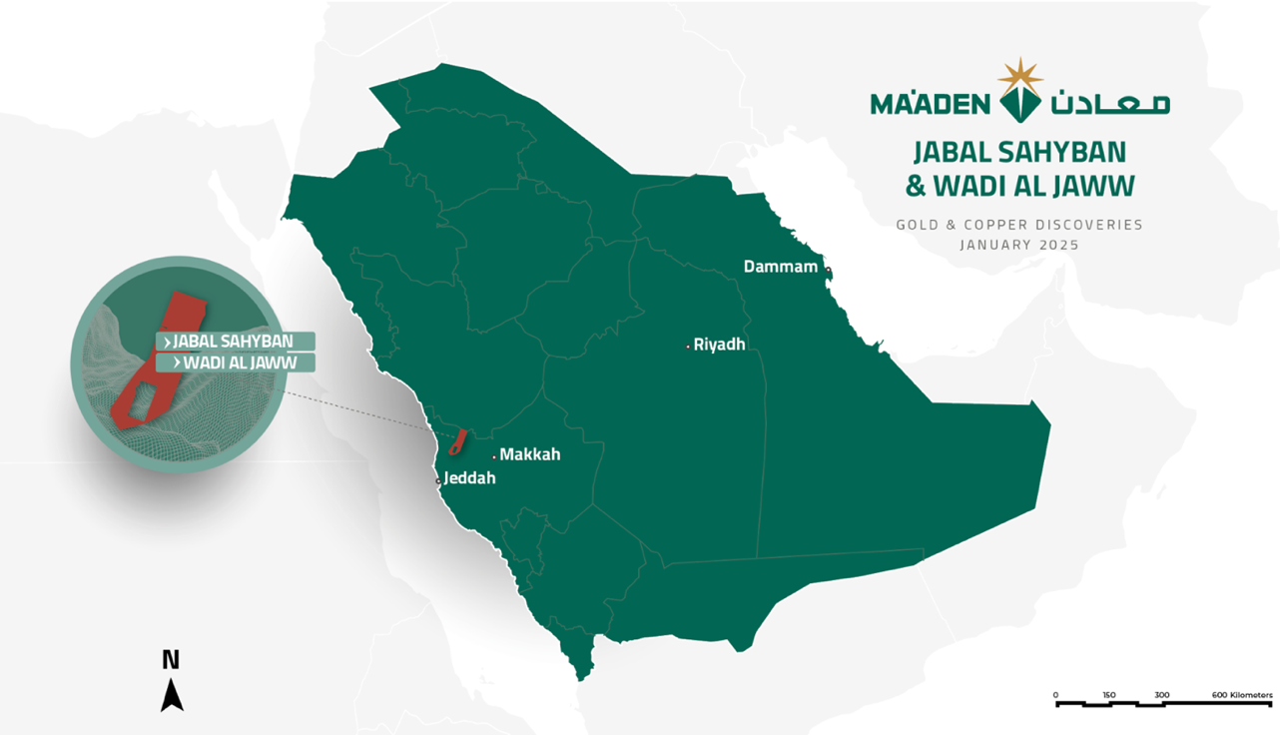

Figure 1 Plan view of the Kingdom of Saudi Arabia with Wadi Al Jaww and Jabal Shayban
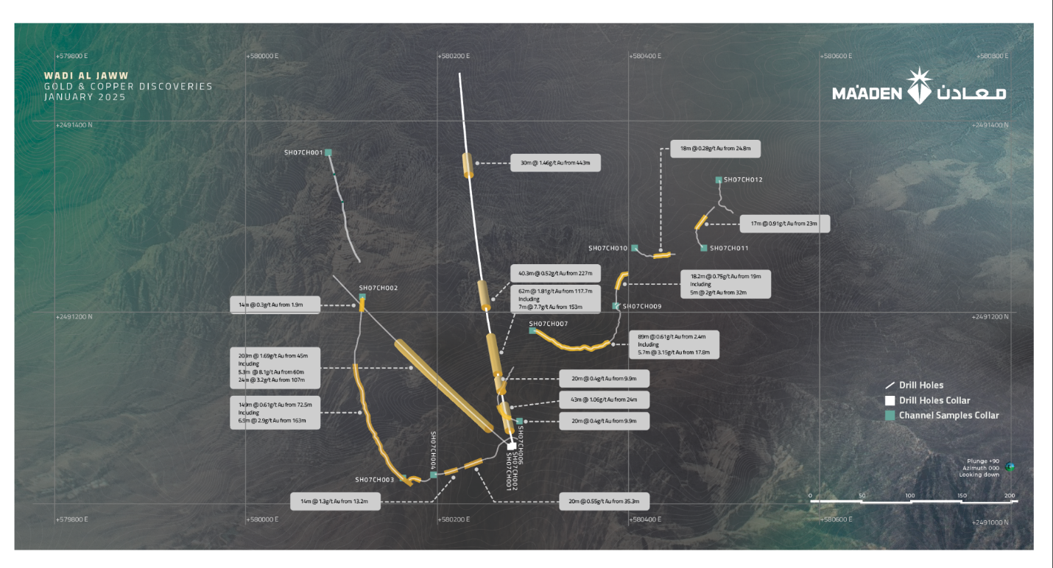
Figure 2 Wadi Al Jaww Plan View
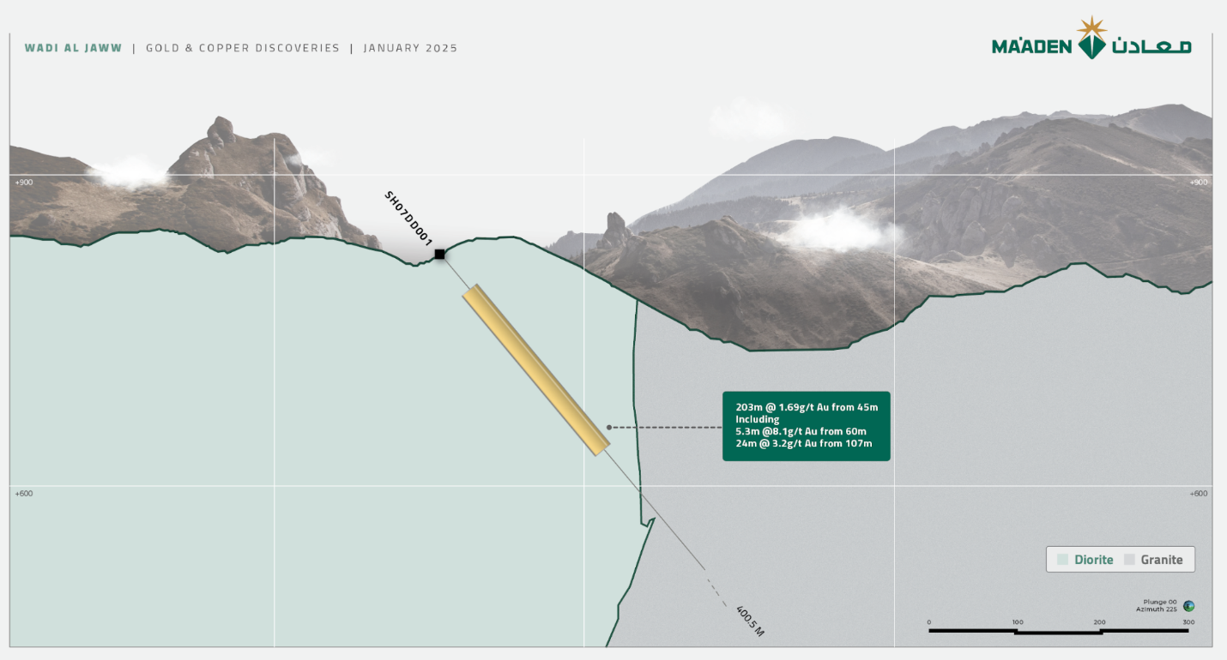
Figure 3 Wadi Al Jaww sections 1
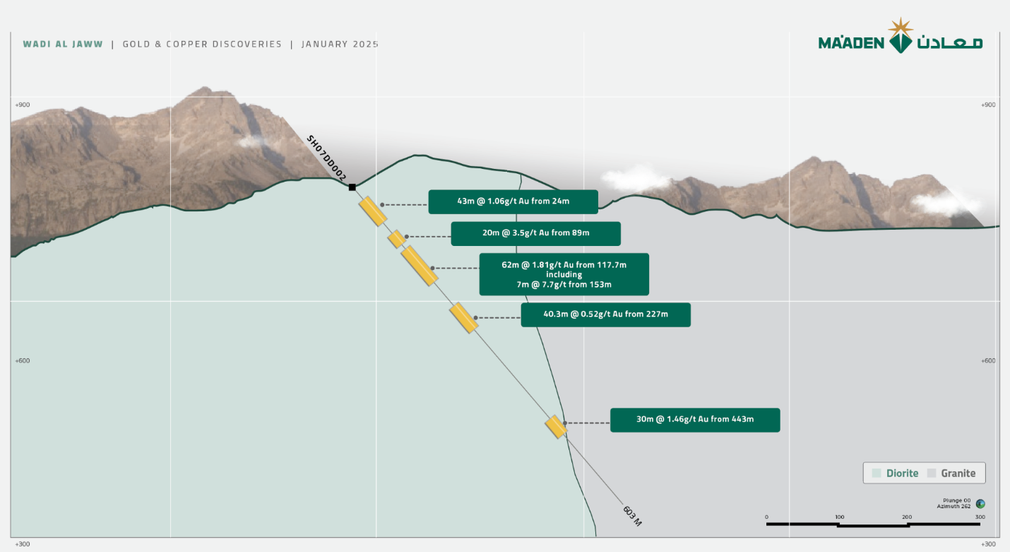
Figure 4 Wadi Al Jaww sections 2

Table 1 Wadi Al Jaww Collar
Hole_iD | max_depth | x | y | z | Program Stage | hole type | azimuth | dip | Cordinate System
SH07DD001 | 400.5 | 580276.44 | 2491059.47 | 823.75 | Exploration | DD | 305 | -50 | UTM84-Z37N
SH07DD002 | 603.4 | 580279.33 | 2491060.87 | 823.93 | Exploration | DD | 340 | -50 | UTM84-Z37N

Table 2 Wadi Al Jaww Intercepts
Hole_ID | From (m) | To (m) | Length (m) | Au (g/t)
SH07DD001 | 45.0 | 248.0 | 203.0 | 1.70
Including | 60.0 | 65.4 | 5.3 | 8.19
Including | 107.0 | 131.0 | 24.0 | 3.20
SH07DD002 | 24.0 | 67.0 | 43.0 | 1.02
SH07DD002 | 89.0 | 109.0 | 20.0 | 3.35
SH07DD002 | 117.7 | 180.0 | 62.3 | 1.81
Including | 153.0 | 160.0 | 7.0 | 7.70
SH07DD002 | 227.7 | 268.0 | 40.3 | 0.52
SH07DD002 | 443.0 | 473.0 | 30.0 | 1.46

Table 3 Wadi Al Jaww Channel Sample Collar location
Hole ID | max_depth | x | y | z | Program Stage | hole type | azimuth | dip | Cordinate System
SH07CH001 | 121.37 | 580,086 | 2,491,366 | 742 | EXP | Channel | 163 | 13 | UTM84-Z37N
SH07CH002 | 221.65 | 580,122 | 2,491,216 | 765 | EXP | Channel | 183 | 19 | UTM84-Z37N
SH07CH003 | 33.66 | 580,164 | 2,491,027 | 786 | EXP | Channel | 117 | 15 | UTM84-Z37N
SH07CH004 | 108.85 | 580,196 | 2,491,031 | 802 | EXP | Channel | 89 | 27 | UTM84-Z37N
SH07CH006 | 77.94 | 580,286 | 2,491,086 | 838 | EXP | Channel | 293 | 16 | UTM84-Z37N
SH07CH007 | 4.99 | 580,313 | 2,491,076 | 832 | EXP | Channel | 294 | 5 | UTM84-Z37N
SH07CH008 | 142.16 | 580,300 | 2,491,181 | 866 | EXP | Channel | 117 | 25 | UTM84-Z37N
SH07CH009 | 41.31 | 580,386 | 2,491,207 | 894 | EXP | Channel | 25 | 13 | UTM84-Z37N
SH07CH010 | 49.07 | 580,406 | 2,491,267 | 901 | EXP | Channel | 117 | 19 | UTM84-Z37N
SH07CH011 | 54.84 | 580,479 | 2,491,267 | 919 | EXP | Channel | 315 | 14 | UTM84-Z37N
SH07CH012 | 48.62 | 580,494 | 2,491,338 | 929 | EXP | Channel | 180 | 9 | UTM84-Z37N
SH07CH013 | 1.02 | 580,520 | 2,491,294 | 941 | EXP | Channel | 90 | 12 | UTM84-Z37N
SH07CH014 | 21.91 | 580,567 | 2,492,000 | 902 | EXP | Channel | 194 | 6 | UTM84-Z37N
SH07CH015 | 40.38 | 580,532 | 2,492,031 | 884 | EXP | Channel | 33 | 4 | UTM84-Z37N

Table 4 Wadi Al Jaww Channel Samples intercepts
Hole_ID | From(m) | To(m) | length(m) | Au (g/t)
SH07CH002 | 1.95 | 16.43 | 14.48 | 0.295
SH07CH002 | 72.51 | 221.8 | 149.29 | 0.619
Including | 163.54 | 170.45 | 6.91 | 2.928
SH07CH003 | 2.04 | 20.95 | 18.91 | 0.603
SH07CH004 | 13.28 | 27.33 | 14.05 | 1.334
SH07CH004 | 35.3 | 55.53 | 20.23 | 0.557
SH07CH006 | 9.94 | 30.82 | 20.88 | 0.481
SH07CH008 | 2.46 | 91.99 | 89.53 | 0.616
Including | 17.82 | 23.54 | 5.72 | 3.164
SH07CH009 | 19.21 | 37.47 | 18.26 | 0.775
Including | 32.47 | 37.47 | 5 | 2.002
SH07CH010 | 24.35 | 42.99 | 18.64 | 0.282
SH07CH011 | 23.19 | 40.45 | 17.26 | 0.981
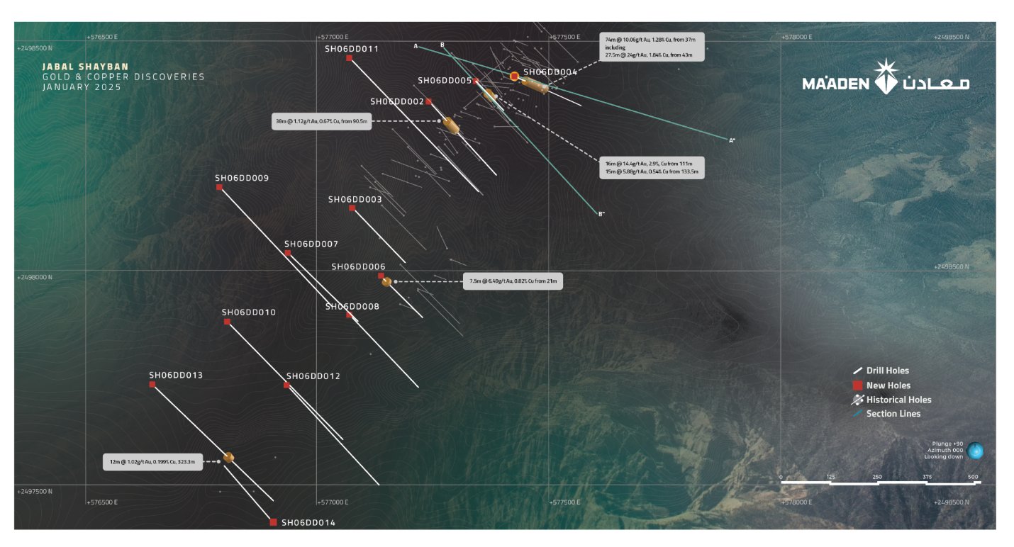
Figure 5 Jabal Shayban Plan view
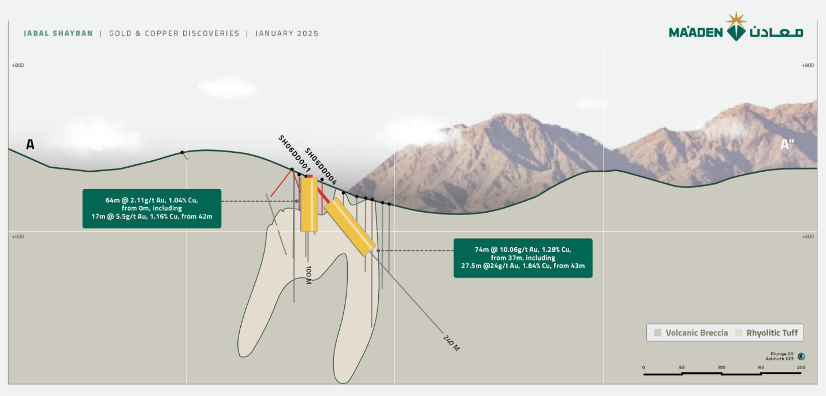
Figure 6 Jabal Shayban sections 1
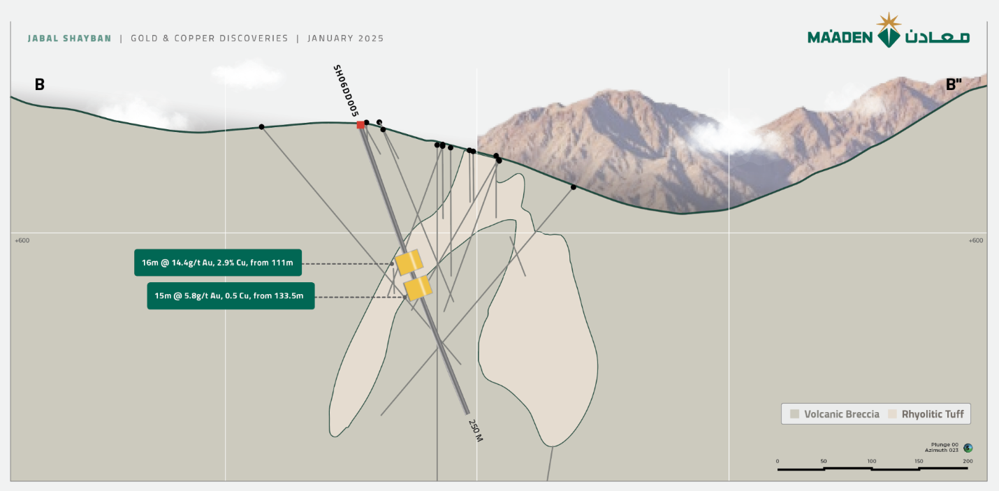
Figure 7 Jabal Shayban sections 2

Table 5 Jabal Shayban Collar
Hole_ID | max_depth | x | y | z | Program Stage | hole type | azimuth | dip | Cordinate System
SH06DD001 | 100 | 577424.84 | 2498419.41 | 669.42 | Exploration | DD | 0 | -90 | UTM84-Z37N
SH06DD002 | 320 | 577238.96 | 2498365.89 | 646.09 | Exploration | DD | 135 | -50 | UTM84-Z37N
SH06DD003 | 317.8 | 577075.06 | 2498135.86 | 626.81 | Exploration | DD | 135 | -60 | UTM84-Z37N
SH06DD004 | 240 | 577425.87 | 2498419.07 | 669.39 | Exploration | DD | 110 | -50 | UTM84-Z37N
SH06DD005 | 250 | 577341.84 | 2498409.76 | 711.15 | Exploration | DD | 135 | -70 | UTM84-Z37N
SH06DD006 | 175 | 577136.63 | 2497988.87 | 622.51 | Exploration | DD | 135 | -90 | UTM84-Z37N
SH06DD007 | 315 | 576934.6 | 2498039.3 | 618.38 | Exploration | DD | 135 | -50 | UTM84-Z37N
SH06DD008 | 330.2 | 577068.08 | 2497905.98 | 622.13 | Exploration | DD | 135 | -50 | UTM84-Z37N
SH06DD009 | 515 | 576787.83 | 2498181.02 | 653.34 | Exploration | DD | 135 | -50 | UTM84-Z37N
SH06DD010 | 512.2 | 576803.65 | 2497891.35 | 613.84 | Exploration | DD | 135 | -50 | UTM84-Z37N
SH06DD011 | 600 | 577067.3 | 2498460.63 | 699.81 | Exploration | DD | 135 | -50 | UTM84-Z37N
SH06DD012 | 413.5 | 576932.52 | 2497753.98 | 619.83 | Exploration | DD | 135 | -50 | UTM84-Z37N
SH06DD013 | 503.7 | 576642.53 | 2497754.88 | 618.79 | Exploration | DD | 135 | -50 | UTM84-Z37N
SH06DD014 | 250 | 576903.66 | 2497457.58 | 651.06 | Exploration | DD | 315 | -50 | UTM84-Z37N

Table 6 Jabal Shayban Intercepts
Hole_ID | From(m) | To(m) | length(m) | Au (g/t) | Cu (%) | Au_Eqv
SH06DD001 | 0 | 64.0 | 64.0 | 2.11 | 1.04 | 3.13
Including | 42.0 | 59.8 | 17.8 | 5.54 | 1.60 | 7.11
SH06DD002 | 90.5 | 129.1 | 38.6 | 1.12 | 0.68 | 1.79
SH06DD004 | 37.0 | 111.0 | 74.0 | 10.06 | 1.28 | 11.32
Including | 43.0 | 70.5 | 27.5 | 24.24 | 1.84 | 26.05
SH06DD005 | 111.0 | 127.0 | 16.0 | 14.40 | 2.91 | 17.26
SH06DD005 | 133.5 | 149.0 | 15.5 | 5.88 | 0.54 | 6.41
SH06DD006 | 12 | 17 | 5 | 1.416 | 0.127 | 1.54
SH06DD006 | 21.0 | 28.5 | 7.5 | 6.49 | 0.83 | 7.30
SH06DD006 | 35.4 | 41 | 5.6 | 1.521 | 1.239 | 2.74
SH06DD013 | 323.3 | 336.0 | 12.7 | 1.03 | 0.20 | 1.22

Competent Person’s Statement
Information in this announcement is based on current and historic Exploration Results compiled by Maaden exploration under the guidance of Dr Darryl Clark who is a Fellow of the Australasian Institute of Mining and Metallurgy. Dr Clark is Senior Vice President of Exploration and Resource Development in Maaden and has sufficient experience which is relevant to the style of Mineralisation and type of deposit under consideration and to the activity he is undertaking to qualify as a Competent Person as defined in the 2012 Edition of the ‘Australasian Code for Reporting of Exploration Results, Mineral Resources and Ore Reserves (JORC 2012).
Dr Darrly Clark consents to the inclusion in this release of the matters based on his information in the form and context in which it appears.

